

# SERVERLESS IMAGE PROCESSING

Discover the power of AWS serverless image processing, an innovative solution that improves efficiency, scalability, and scalability, and user satisfaction. With serverless image processing, you'll be able to process images faster and more and more reliably than ever before.

## Table of Contents

1. Introduction
2. What is Serverless Architecture?
3. Benefits of Serverless Image Processing
4. Key Components of a Serverless Image Processing Pipeline
5. Setting Up Serverless Image Processing
   * Using AWS Lambda
   * Using Azure Functions
   * Using Google Cloud Functions
6. Security Considerations
7. Cost Optimization
8. Conclusion
9. References

## What is Serverless Architecture?

Serverless architecture is a cloud computing model where the cloud provider dynamically manages the allocation and provisioning of servers. Applications built using serverless architecture are designed to scale automatically and handle varying loads efficiently. Serverless computing is event-driven and executes code in response to events, eliminating the need for server management.

### Key Features of Serverless Architecture:

* **No Server Management**: Developers focus on writing code, while the cloud provider manages the infrastructure.
* **Automatic Scaling**: Applications scale automatically based on demand.
* **Cost-Efficiency**: Pay-as-you-go pricing model ensures that you only pay for the compute time you use.
* **Event-Driven**: Functions are triggered by events, such as HTTP requests, file uploads, or database changes.

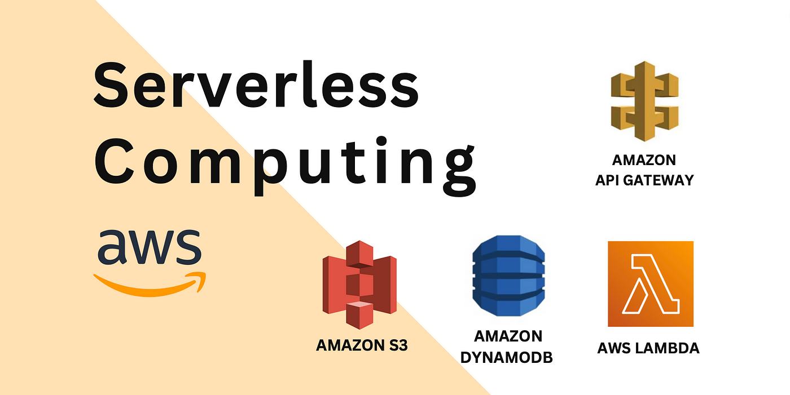

## Setting Up Serverless Image Processing

### Using AWS Lambda

#### Step-by-Step Guide:

1. **Create an S3 Bucket**:
   * Create a source bucket to upload original images.
   * Create a destination bucket to store processed images.
2. **Create a Lambda Function**:
   * Go to the AWS Lambda console and create a new function.
   * Write the image processing code (e.g., using Python with libraries like Pillow).
   * Set up the S3 trigger for the source bucket to invoke the Lambda function.
3. **Configure Permissions**:
   * Ensure the Lambda function has the necessary permissions to read from the source bucket and write to the destination bucket.
4. **Deploy and Test**:
   * Upload an image to the source bucket and verify that the processed image appears in the destination bucket





## How it Works



### User Uploads Image

When a user uploads an image, AWS

AWS Lambda is triggered.

### Lambda Function Processes Processes Image

Our serverless function processes the image and stores the result in an S3 bucket.

### Processed Images Stored in S3

Once processed, the images are stored in an S3 bucket for easy retrieval and distribution.

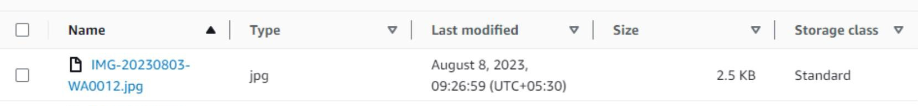**Before Processing**

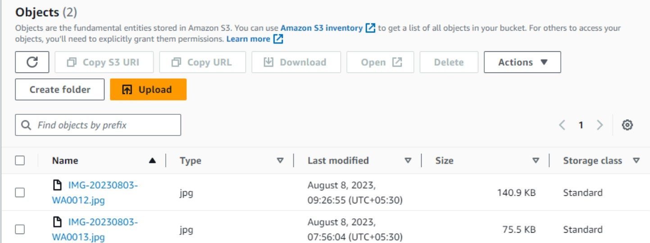

**After Processing**

## The Benefits of Serverless Image Processing

### Scalability

**1**

Thanks to the auto-scaling features of AWS, businesses can handle any workload needed for image processing, no matter how big or small.

### Reliability

Our solution is built on AWS Lambda, a fully managed and resilient compute service.

**2**

### Flexibility

Being serverless means our solution can handle any workload without worrying about server settings.

**3**

## Examples of Image Processing Use Cases

### eCommerce

Enhance product images by adjusting colors, brightness and contrast in order to highlight product details and improve marketing strategy.

Media and Entertainment

Use image processing to help recognize faces, objects, and scenes, which can enable dynamic features and enhanced user engagement.

### Healthcare

Image processing can help in medical diagnoses by analyses of medical images such as X-rays and CT scans, detecting specific medical disorders, tumors or other abnormal changes.

## Improved User Satisfaction

### Better User Experience

**1**

**2**

**3**



**Improved Customer Loyalty**

Our solution can help you build lasting relationships with customers by improving engagement with your brand and boosting

customer satisfaction.

Our serverless image processing solution helps reduce downtime and improve overall user satisfaction, keeping your customers happy and engaged.

### Increased Productivity

With our solution, businesses can focus on core activities rather than worrying about image processing, ultimately increasing

productivity.



## Conclusion and Key Takeaways

* Serverless image processing is a cost-effective solution that can handle any workload, no matter how big or small.
* It can improve user satisfaction and drive customer loyalty while reducing downtime and improving overall efficiency.
* With image processing, businesses can create more engaging content and increase productivity, keeping pace with today's digital age.

## Conclusion

Serverless architecture provides a scalable, cost-effective, and efficient solution for image processing tasks. By leveraging cloud services like AWS Lambda, Azure Functions, or Google Cloud Functions, you can build a robust image processing pipeline without the hassle of managing servers